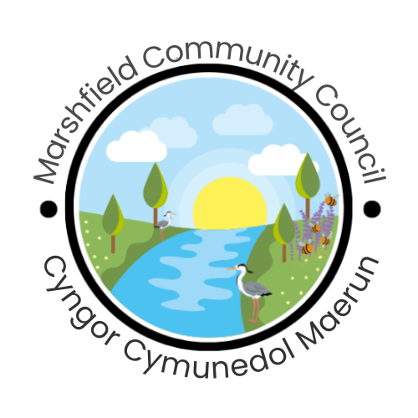

***Serving the Communities of Castleton and Marshfield***

*Chairperson: Cath Davis*

*Clerk:* Mr G C Thomas 4 Kenilworth Road Newport South Wales NP19 8JQ

*Tel:* 01633 375812 [marshfieldcommunitycouncil@gmail.com](mailto:marshfieldcommunitycouncil@gmail.com)

**Marshfield Community Council Newsletter Spring 2024**

Marshfield Community Council has a colourful new logo designed by our very own Councillor Steve Walsh-Jones. The council hopes that residents will agree that it is a stunning colourful depiction of the rural nature of our villages and the important wildlife contained in it. On May 9th the community council annual meeting took place when we welcomed our newest councillor Srinivas onto the council; our 11 vacancies are now filled.

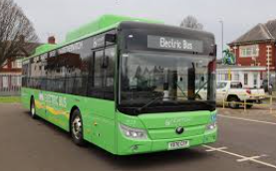**NEW MARSHFIELD BUS SERVICE**

After consultation with the community and substantial efforts by the local bus campaign group, we were pleased to see the introduction of the new 31A and 31C bus services, funded by Newport City Council, on Tuesday 2nd April 2024. The new route for the electric bus links Peterstone, St Brides, Lighthouse Park, Marshfield and Castleton with Dyffryn and Newport. The bus has a low flat floor for easy access and space for pushchair and wheelchair users.Marshfield Community Council has helped to distribute bus timetables and encourages the use of the new bus to ensure its success and the continuation of the service. If there is sufficient desire expressed, we hope to be able to request an extension of the route to include Crickhowell Road in St Mellons for access to the supermarket, doctors’ surgery, dentist and optician in future.

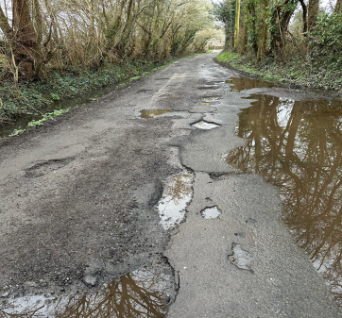

**‘LET’S FIX IT’ CHURCH LANE CAMPAIGN**

The community council has formed a campaign group with some residents fed up with the state of the road surface of Church Lane near St Marys Church. Many signatures have been collected for a petition to be presented to Newport City Council. One of our city councillors is arranging for us to meet a Newport Council highways officer to discuss this issue on site. If you wish to sign the petition or wish to join the campaign group please contact [marshfieldcommunitycouncil@gmail.com](mailto:marshfieldcommunitycouncil@gmail.com)

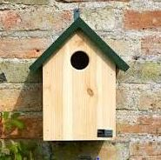**BIRD BOXES**

As part of our work promoting biodiversity and improving our ***Local Places for Nature****,* Marshfield Community Council is keen to encourage local children and young people to become involved with the construction and placing of bird nesting boxes at suitable sites around Marshfield and Castleton. Thanks to several generous donations from local individuals and businesses (Falcon Low Loaders Ltd, Block Paving Specialists, Mr David Evans, AJM Landscaping), we are now able to purchase suitable timber to create a number of kits for local children, including Guides, Scouts, school children and the church youth group, to build nest boxes later in the year ready for birds to use next spring.



**NEW COMMUNITY COUNCIL WEBSITE**

Marshfield Community Council Digital and Media sub-group is working on updating and renewing the council website. This will mean the council will be able to facilitate greater interaction with our community online. The new site will be built alongside the current one so that it can go live once completed. The new council logo mentioned above was adopted at our last council meeting and will be used from now on. The council welcomes any ideas you may have for website content and feedback on our new logo.

**MARSHFIELD VILLAGE HALL**

The Marshfield Village Hall committee is excited to announce that their Annual General Meeting will be held on **Tuesday 2nd July** **2024 @7pm** at the village hall. This important event provides an opportunity for residents to learn more about the committee’s work, share their ideas, and get involved with enhancing our community life. This year, the committee is actively looking for new trustees to help manage a variety of events and initiatives. Trustees play a vital role in organising community gatherings such as the popular ‘Picnic in the Park’, the annual bonfire fireworks and other activities that bring our village together. Being a trustee is a rewarding way to contribute to the vibrancy and well-being of Marshfield, ensuring that our village hall continues to be a hub of activity and support. The committee is also seeking enthusiastic volunteers to help run ***The Village Coffee Shop*** which opens on weekends. This is a perfect opportunity for those who enjoy engaging with the community and have a few hours to spare to help out. Volunteering is very rewarding and the coffee shop is a great way to meet new people, provide a valued service, and support the hall’s ongoing activities. If you are interested in any of the above please come to our AGM, visit [www.marshfieldvillagehall.co.uk](http://www.marshfieldvillagehall.co.uk) or email [bookings@marshfieldvillagehall.org.uk](mailto:bookings@marshfieldvillagehall.org.uk)

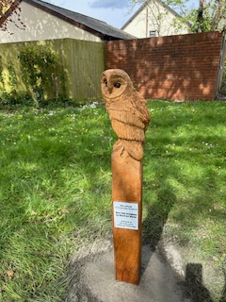

**BARN OWL SCLPTURE**

One barn owl sculpture sponsored by The Living Levels Landscape Partnership has recently been sited in amongst the trees at our village green, Groes Corner. The wooden sculpture looks very ‘at home’ in amongst the trees and greenery. The wood sculpture was obtained from Wood Art Works in Caerleon who provide bespoke wood sculptures and has completed many commissions for the Living Levels [www.woodartworks.co.uk](http://www.woodartworks.co.uk)

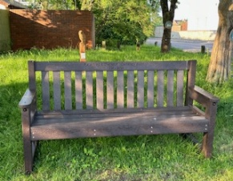**MARSHFIELD WI 100 YEARS CELEBRATION BENCH**

Also recently sited at Groes Corner, Marshfield Women’s Institute has provided a lovely bench for the community in celebration of their 100th year anniversary. The council worked with the WI in organising the positioning of the bench at this site. Marshfield WI meets at Castleton Village Hall on the first Tuesday monthly at 7.30pm and more information can be found on [www.womens-institute.org.uk/gwent](http://www.womens-institute.org.uk/gwent) or email [marshfieldwi18@gmail.com](mailto:marshfieldwi18@gmail.com)

**VILLAGE HALL LITTER BINS**

The burnt out litter bin at Marshfield Village Hall playing fields near St Mellons Road access has been replaced for the community council by Newport City Council. The cost to the community council was £400 and we hope that this one will not be vandalised. Additionally, the village hall and the community council have collaborated in providing 4 new bins that will be installed around the play areas at a cost £1440. These are larger covered bins which will help to prevent overflow and spread of litter which has been a real problem. We respectfully remind residents that these bins are for litter only and not for domestic waste or dirty nappies; the latter should be taken home and disposed of in dedicated hygiene bags supplied by Newport City Council.

**VILLAGE LITTER BINS AND FLYTIPPING**

Since the 3-weekly bin collections began it has been noticed that public litter bins throughout the village are being used and filled with domestic waste. Particularly bad is the bin outside Marshfield Stores and Pharmacy, where car users are emptying their waste from vehicles instead of taking it home. MCC has requested a larger covered bin at this site but the local authority is unwilling to change it although they did put a couple of lamp post bins close by. Please be considerate to the village and if this bin is full then take your waste home with you. There has also been an increase in fly-tipping on the lanes into the village of Marshfield namely Wellfield Road, St. Mellons Road and Ty Mawr Lane; the B4239 was also blocked near Peterstone recently. Please report any fly tipping to Newport City Council (01633 656656 / [info@newport.gov.wales](mailto:info@newport.gov.wales)) with any vehicle details if observed.

**FORTHCOMING EVENTS OF INTEREST**

Saturday June 22nd and Sunday June 23rd **Football Festival** hosted by Marshfield Senior Football Team at Marshfield Village Hall.

Saturday June 22nd Save the Six Bells Campaign **Summer Fete** at Peterstone Village Hall

Sunday July 7th Marshfield Junior Football Club **Family Fun Day** at Marshfield Village Hall 10am to 6pm

Sunday 16th August Marshfild **Cars and Coffee** 9am to 1pm

Friday 27th – Sunday 29th September **Scarecrow Festival** organised by MCC